UNITED STATES
SECURITIES AND EXCHANGE COMMISSION
Washington, D.C. 20549

FORM 8-K

CURRENT REPORT
Pursuant to Section 13 OR 15(d)
of The Securities Exchange Act of 1934
Date of Report (Date of earliest event reported): October 8, 2026

Tenax Therapeutics, Inc.
(Exact name of registrant as specified in its charter)

Delaware |  | 001-34600 |  | 26-2593535
(State or other jurisdiction  of incorporation) |  | (Commission  File Number) |  | (IRS Employer  Identification No.)
101 Glen Lennox Drive, Suite 300
Chapel Hill, North Carolina 27517
(Address of principal executive offices) (Zip Code)
919-855-2100
(Registrant’s telephone number, including area code)

Check the appropriate box below if the Form 8-K filing is intended to simultaneously satisfy the filing obligation of the registrant under any of the following provisions:

☐ | Written communications pursuant to Rule 425 under the Securities Act (17 CFR 230.425)

☐ | Soliciting material pursuant to Rule 14a-12 under the Exchange Act (17 CFR 240.14a-12)

☐ | Pre-commencement communications pursuant to Rule 14d-2(b) under the Exchange Act (17 CFR 240.14d-2(b))

☐ | Pre-commencement communications pursuant to Rule 13e-4(c) under the Exchange Act (17 CFR 240.13e-4(c))
Securities registered pursuant to Section 12(b) of the Act:

Title of each class |  | Trading  Symbol(s) |  | Name of each exchange  on which registered
Common Stock, $0.0001 par value per share |  | TENX |  | The Nasdaq Stock Market LLC
Indicate by check mark whether the registrant is an emerging growth company as defined in Rule 405 of the Securities Act of 1933 (17 CFR 230.405) or Rule 12b-2 of the Securities Exchange Act of 1934 (17 CFR 240.12b-2).
Emerging growth company ☐
If an emerging growth company, indicate by check mark if the registrant has elected not to use the extended transition period for complying with any new or revised financial accounting standards provided pursuant to Section 13(a) of the Exchange Act. ☐

Item 8.01 | Other Events.
As previously announced, Tenax Therapeutics, Inc. (the “Company”) is enriching its LEVEL-2 clinical trial based on key learnings from its recently completed Phase 3 LEVEL trial of TNX-103 in PH-HFpEF. The Company intends to amend LEVEL-2 enrollment criteria, as set forth in the attached Investor Presentation. To maximize the enrollment of these patients, whom LEVEL results suggest are those most likely to demonstrate improved exercise tolerance in the primary endpoint of LEVEL-2, the Company has temporarily paused enrollment in LEVEL-2. Enrollment may resume at each site as the amended protocol goes into effect there. The Company has requested a Type C meeting with the U.S. Food and Drug Administration to discuss the overall development of levosimendan. The Company’s corporate presentation, which it intends to use with investors and analysts, has been updated to address these matters and is attached hereto as Exhibit 99.1 and incorporated herein by reference.

Item 9.01 | Financial Statements and Exhibits.
(d) Exhibits.

Exhibit 99.1 |  | Investor Presentation, dated October 8, 2026.
Exhibit 104 |  | Cover Page Interactive Data File (embedded within the Inline XBRL document).

SIGNATURES
Pursuant to the requirements of the Securities Exchange Act of 1934, the registrant has duly caused this report to be signed on its behalf by the undersigned hereunto duly authorized.

Date: October 8, 2026 |  |  |  | TENAX THERAPEUTICS, INC.
 |  |  |  | By: |  | /s/ Christopher T. Giordano
 |  |  |  | Name: |  | Christopher T. Giordano
 |  |  |  | Title: |  | President and Chief Executive Officer

Corporate Presentation October 2026 Exhibit 99.1

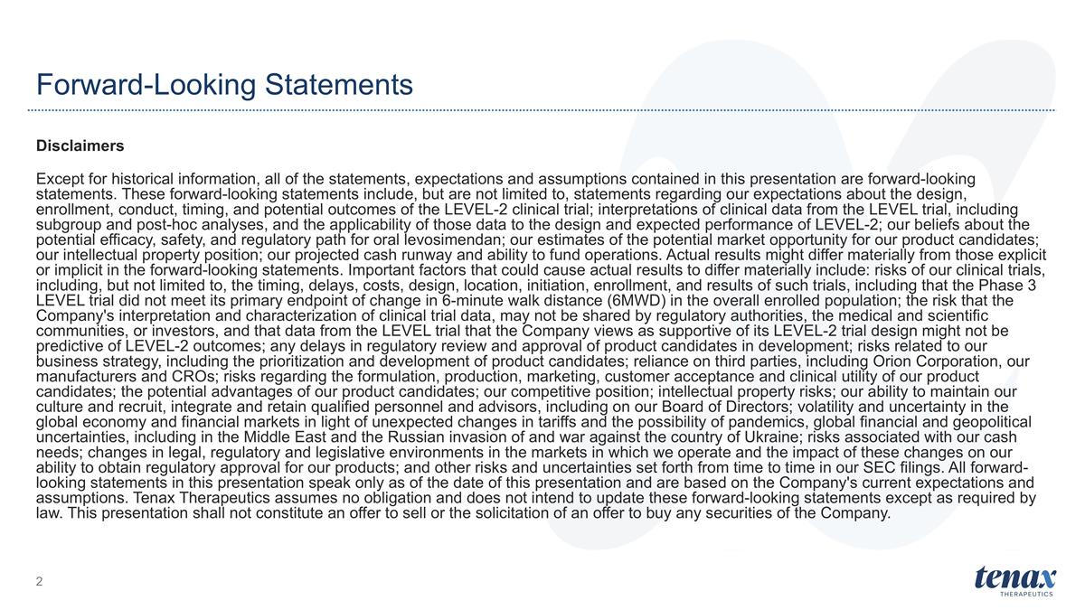
Forward-Looking Statements Disclaimers Except for historical information, all of the statements, expectations and assumptions contained in this presentation are forward-looking statements. These forward-looking statements include, but are not limited to, statements regarding our expectations about the design, enrollment, conduct, timing, and potential outcomes of the LEVEL-2 clinical trial; interpretations of clinical data from the LEVEL trial, including subgroup and post-hoc analyses, and the applicability of those data to the design and expected performance of LEVEL-2; our beliefs about the potential efficacy, safety, and regulatory path for oral levosimendan; our estimates of the potential market opportunity for our product candidates; our intellectual property position; our projected cash runway and ability to fund operations. Actual results might differ materially from those explicit or implicit in the forward-looking statements. Important factors that could cause actual results to differ materially include: risks of our clinical trials, including, but not limited to, the timing, delays, costs, design, location, initiation, enrollment, and results of such trials, including that the Phase 3 LEVEL trial did not meet its primary endpoint of change in 6-minute walk distance (6MWD) in the overall enrolled population; the risk that the Company's interpretation and characterization of clinical trial data, may not be shared by regulatory authorities, the medical and scientific communities, or investors, and that data from the LEVEL trial that the Company views as supportive of its LEVEL-2 trial design might not be predictive of LEVEL-2 outcomes; any delays in regulatory review and approval of product candidates in development; risks related to our business strategy, including the prioritization and development of product candidates; reliance on third parties, including Orion Corporation, our manufacturers and CROs; risks regarding the formulation, production, marketing, customer acceptance and clinical utility of our product candidates; the potential advantages of our product candidates; our competitive position; intellectual property risks; our ability to maintain our culture and recruit, integrate and retain qualified personnel and advisors, including on our Board of Directors; volatility and uncertainty in the global economy and financial markets in light of unexpected changes in tariffs and the possibility of pandemics, global financial and geopolitical uncertainties, including in the Middle East and the Russian invasion of and war against the country of Ukraine; risks associated with our cash needs; changes in legal, regulatory and legislative environments in the markets in which we operate and the impact of these changes on our ability to obtain regulatory approval for our products; and other risks and uncertainties set forth from time to time in our SEC filings. All forward-looking statements in this presentation speak only as of the date of this presentation and are based on the Company's current expectations and assumptions. Tenax Therapeutics assumes no obligation and does not intend to update these forward-looking statements except as required by law. This presentation shall not constitute an offer to sell or the solicitation of an offer to buy any securities of the Company.

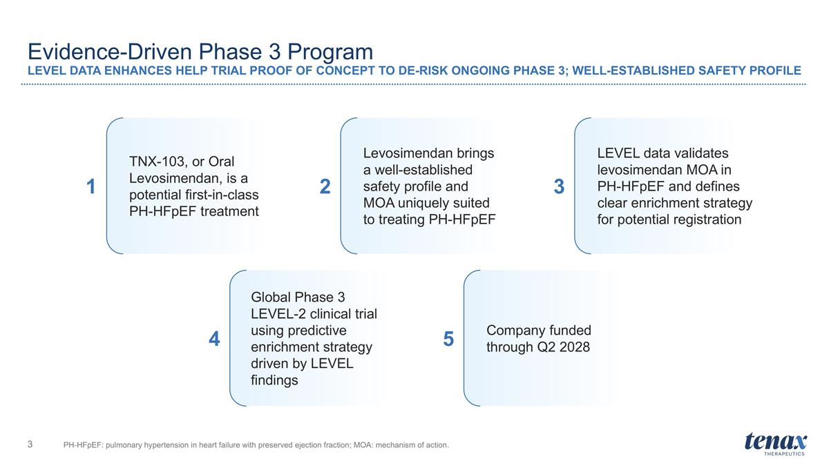
Evidence-Driven Phase 3 Program LEVEL DATA ENHANCES HELP TRIAL PROOF OF CONCEPT TO DE-RISK ONGOING PHASE 3; WELL-ESTABLISHED SAFETY PROFILE PH-HFpEF: pulmonary hypertension in heart failure with preserved ejection fraction; MOA: mechanism of action. TNX-103, or Oral Levosimendan, is a potential first-in-class PH-HFpEF treatment Levosimendan brings a well-established safety profile and MOA uniquely suited to treating PH-HFpEF Global Phase 3 LEVEL-2 clinical trial using predictive enrichment strategy driven by LEVEL findings Company funded through Q2 2028 1 2 3 4 5 LEVEL data validates levosimendan MOA in PH-HFpEF and defines clear enrichment strategy for potential registration

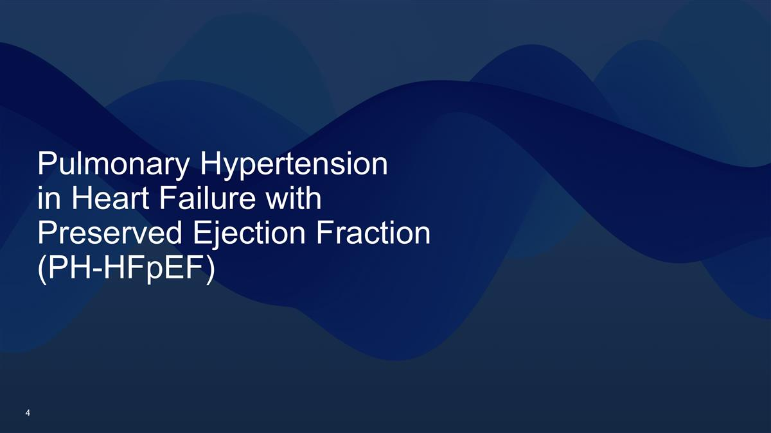
Pulmonary Hypertension in Heart Failure with Preserved Ejection Fraction (PH-HFpEF)

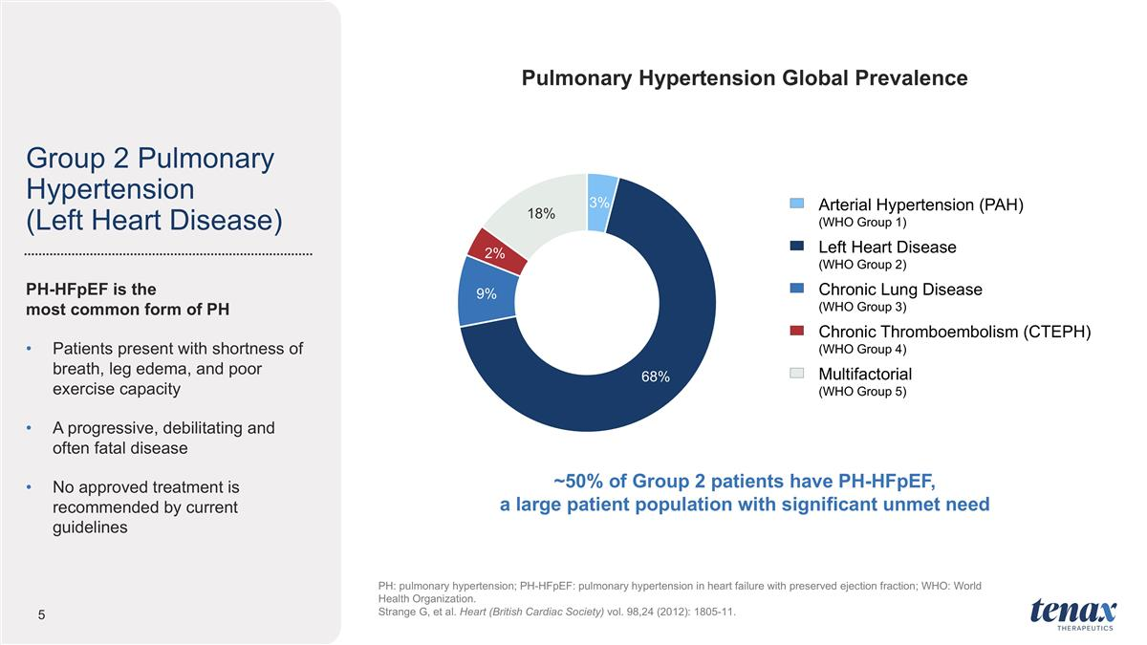
Group 2 Pulmonary Hypertension (Left Heart Disease) PH: pulmonary hypertension; PH-HFpEF: pulmonary hypertension in heart failure with preserved ejection fraction; WHO: World Health Organization. Strange G, et al. Heart (British Cardiac Society) vol. 98,24 (2012): 1805-11. PH-HFpEF is the most common form of PH Patients present with shortness of breath, leg edema, and poor exercise capacity A progressive, debilitating and often fatal disease No approved treatment is recommended by current guidelines Pulmonary Hypertension Global Prevalence Arterial Hypertension (PAH) (WHO Group 1) Left Heart Disease (WHO Group 2) Chronic Lung Disease (WHO Group 3) Chronic Thromboembolism (CTEPH) (WHO Group 4) Multifactorial (WHO Group 5) ~50% of Group 2 patients have PH-HFpEF, a large patient population with significant unmet need

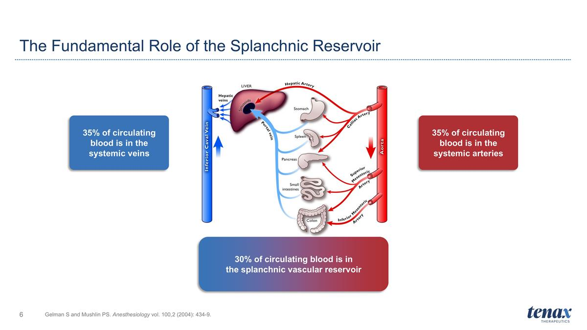
The Fundamental Role of the Splanchnic Reservoir Gelman S and Mushlin PS. Anesthesiology vol. 100,2 (2004): 434-9. 35% of circulating blood is in the systemic veins 35% of circulating blood is in the systemic arteries 30% of circulating blood is in the splanchnic vascular reservoir

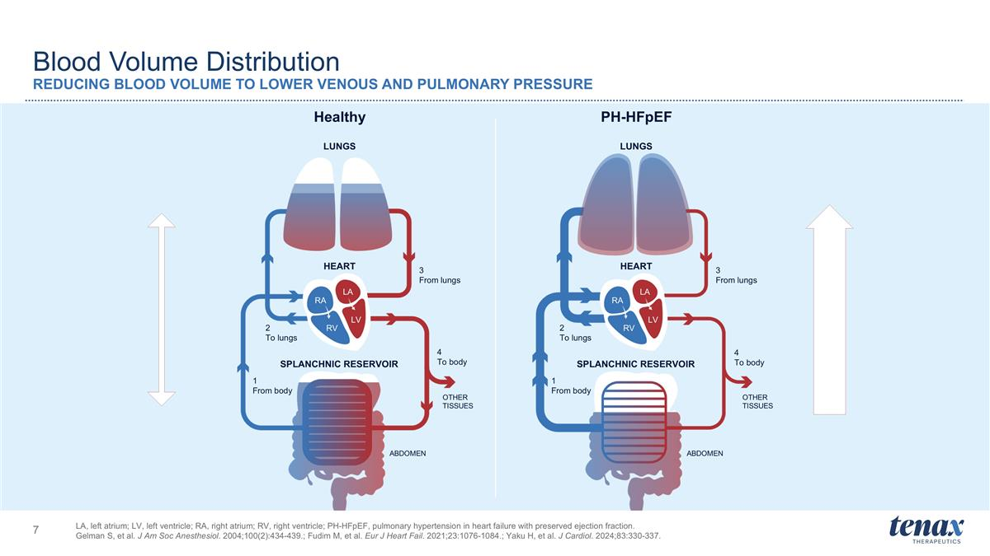
LA, left atrium; LV, left ventricle; RA, right atrium; RV, right ventricle; PH-HFpEF, pulmonary hypertension in heart failure with preserved ejection fraction. Gelman S, et al. J Am Soc Anesthesiol. 2004;100(2):434-439.; Fudim M, et al. Eur J Heart Fail. 2021;23:1076-1084.; Yaku H, et al. J Cardiol. 2024;83:330-337. LUNGS HEART HEART LUNGS SPLANCHNIC RESERVOIR SPLANCHNIC RESERVOIR 1 From body 2 To lungs 3 From lungs 4 To body OTHER TISSUES ABDOMEN 1 From body 2 To lungs 3 From lungs 4 To body OTHER TISSUES ABDOMEN Healthy PH-HFpEF RA RV LA LV Blood Volume Distribution REDUCING BLOOD VOLUME TO LOWER VENOUS AND PULMONARY PRESSURE RA RV LA LV RA RV LA LV

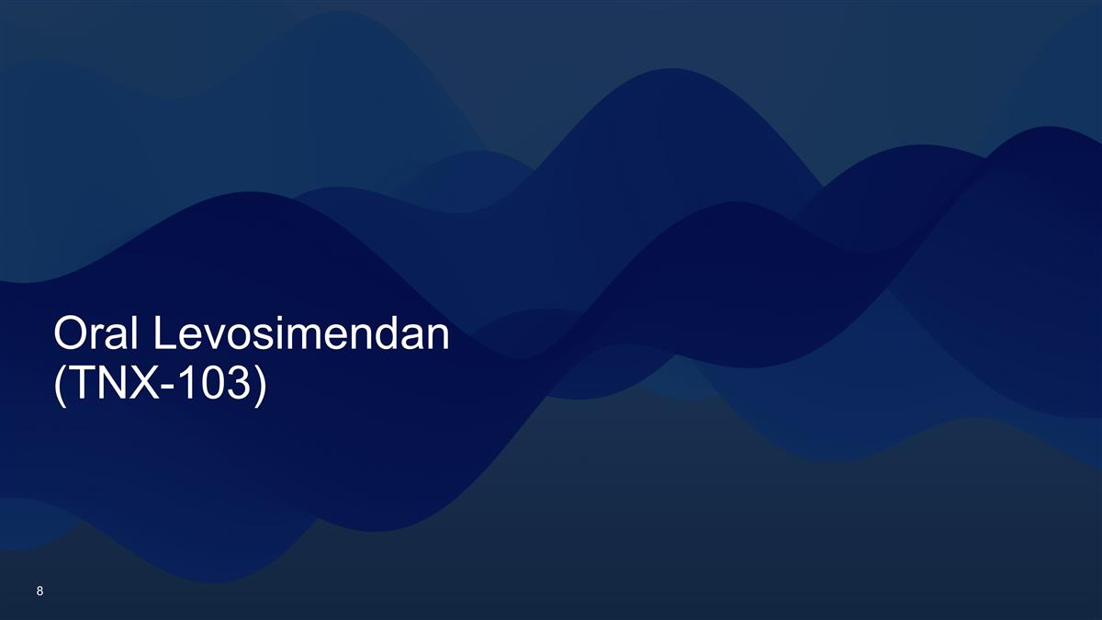
Oral Levosimendan (TNX-103)

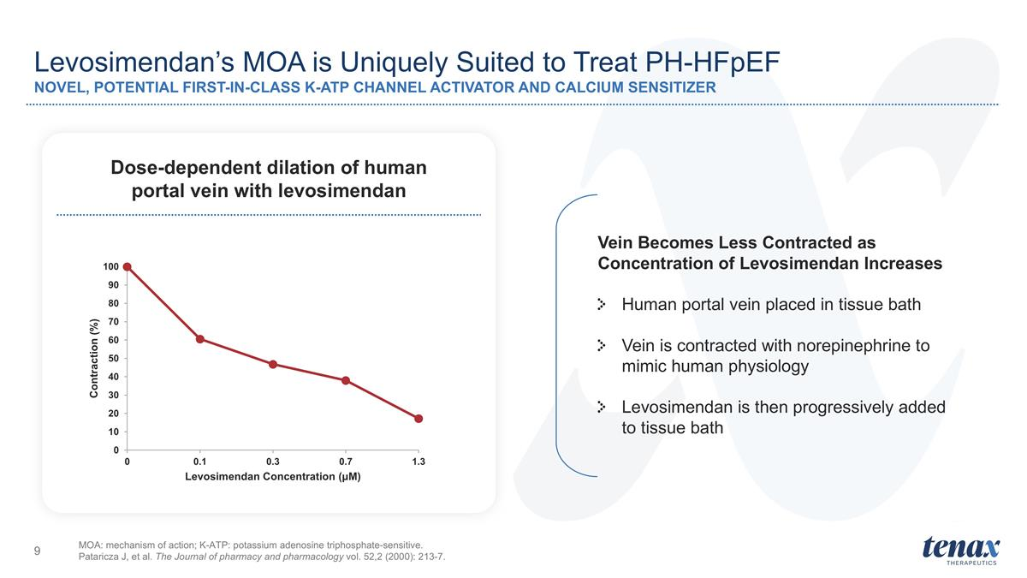
Levosimendan’s MOA is Uniquely Suited to Treat PH-HFpEF NOVEL, POTENTIAL FIRST-IN-CLASS K-ATP CHANNEL ACTIVATOR AND CALCIUM SENSITIZER MOA: mechanism of action; K-ATP: potassium adenosine triphosphate-sensitive. Pataricza J, et al. The Journal of pharmacy and pharmacology vol. 52,2 (2000): 213-7. Dose-dependent dilation of human portal vein with levosimendan Vein Becomes Less Contracted as Concentration of Levosimendan Increases Human portal vein placed in tissue bath Vein is contracted with norepinephrine to mimic human physiology Levosimendan is then progressively added to tissue bath

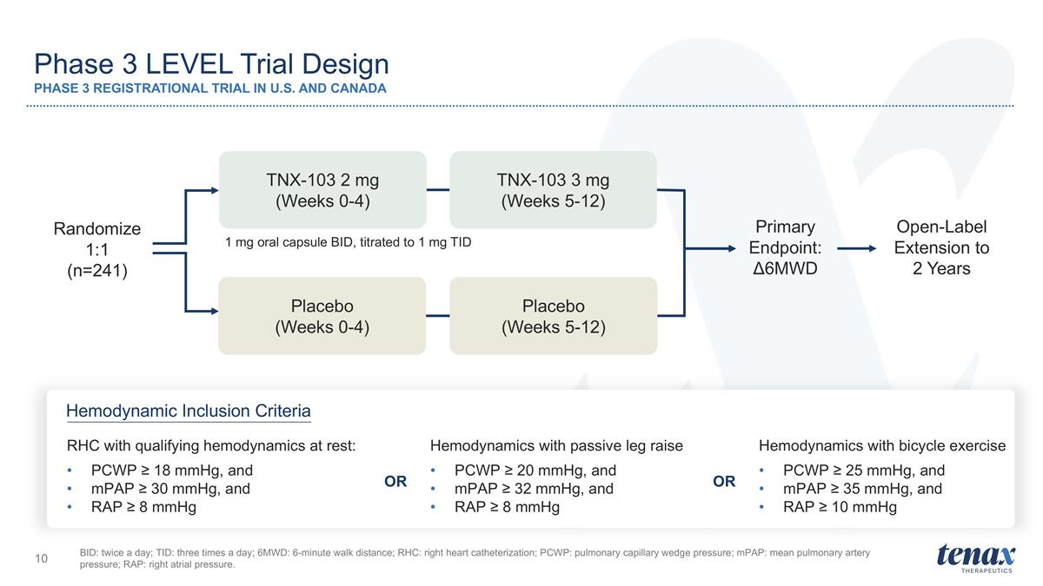
Phase 3 LEVEL Trial Design PHASE 3 REGISTRATIONAL TRIAL IN U.S. AND CANADA BID: twice a day; TID: three times a day; 6MWD: 6-minute walk distance; RHC: right heart catheterization; PCWP: pulmonary capillary wedge pressure; mPAP: mean pulmonary artery pressure; RAP: right atrial pressure. 1 mg oral capsule BID, titrated to 1 mg TID Open-Label Extension to 2 Years TNX-103 2 mg (Weeks 0-4) TNX-103 3 mg (Weeks 5-12) Placebo (Weeks 0-4) Placebo (Weeks 5-12) Primary Endpoint: Δ6MWD Hemodynamic Inclusion Criteria Randomize 1:1 (n=241) RHC with qualifying hemodynamics at rest: PCWP ≥ 18 mmHg, and mPAP ≥ 30 mmHg, and RAP ≥ 8 mmHg Hemodynamics with passive leg raise PCWP ≥ 20 mmHg, and mPAP ≥ 32 mmHg, and RAP ≥ 8 mmHg Hemodynamics with bicycle exercise PCWP ≥ 25 mmHg, and mPAP ≥ 35 mmHg, and RAP ≥ 10 mmHg OR OR

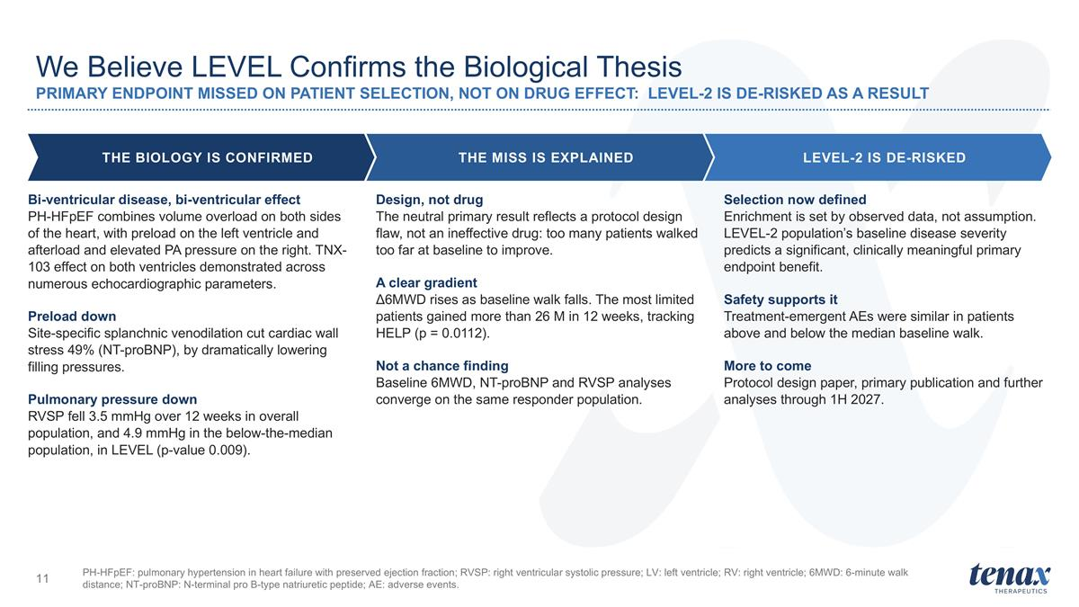
PH-HFpEF: pulmonary hypertension in heart failure with preserved ejection fraction; RVSP: right ventricular systolic pressure; LV: left ventricle; RV: right ventricle; 6MWD: 6-minute walk distance; NT-proBNP: N-terminal pro B-type natriuretic peptide; AE: adverse events. We Believe LEVEL Confirms the Biological Thesis PRIMARY ENDPOINT MISSED ON PATIENT SELECTION, NOT ON DRUG EFFECT: LEVEL-2 IS DE-RISKED AS A RESULT THE BIOLOGY IS CONFIRMED THE MISS IS EXPLAINED LEVEL-2 IS DE-RISKED Bi-ventricular disease, bi-ventricular effect PH-HFpEF combines volume overload on both sides of the heart, with preload on the left ventricle and afterload and elevated PA pressure on the right. TNX-103 effect on both ventricles demonstrated across numerous echocardiographic parameters. Preload down Site-specific splanchnic venodilation cut cardiac wall stress 49% (NT-proBNP), by dramatically lowering filling pressures. Pulmonary pressure down RVSP fell 3.5 mmHg over 12 weeks in overall population, and 4.9 mmHg in the below-the-median population, in LEVEL (p-value 0.009). Design, not drug The neutral primary result reflects a protocol design flaw, not an ineffective drug: too many patients walked too far at baseline to improve. A clear gradient Δ6MWD rises as baseline walk falls. The most limited patients gained more than 26 M in 12 weeks, tracking HELP (p = 0.0112). Not a chance finding Baseline 6MWD, NT-proBNP and RVSP analyses converge on the same responder population. Selection now defined Enrichment is set by observed data, not assumption. LEVEL-2 population’s baseline disease severity predicts a significant, clinically meaningful primary endpoint benefit. Safety supports it Treatment-emergent AEs were similar in patients above and below the median baseline walk. More to come Protocol design paper, primary publication and further analyses through 1H 2027.

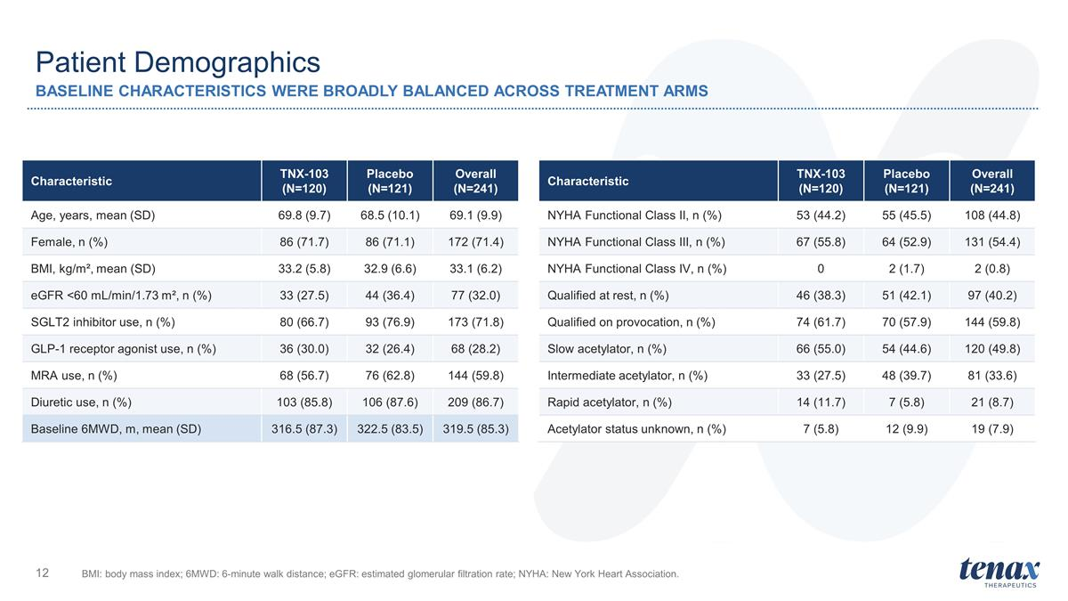
Patient Demographics BASELINE CHARACTERISTICS WERE BROADLY BALANCED ACROSS TREATMENT ARMS BMI: body mass index; 6MWD: 6-minute walk distance; eGFR: estimated glomerular filtration rate; NYHA: New York Heart Association. Characteristic TNX-103 (N=120) Placebo (N=121) Overall (N=241) Age, years, mean (SD) 69.8 (9.7) 68.5 (10.1) 69.1 (9.9) Female, n (%) 86 (71.7) 86 (71.1) 172 (71.4) BMI, kg/m², mean (SD) 33.2 (5.8) 32.9 (6.6) 33.1 (6.2) eGFR <60 mL/min/1.73 m², n (%) 33 (27.5) 44 (36.4) 77 (32.0) SGLT2 inhibitor use, n (%) 80 (66.7) 93 (76.9) 173 (71.8) GLP-1 receptor agonist use, n (%) 36 (30.0) 32 (26.4) 68 (28.2) MRA use, n (%) 68 (56.7) 76 (62.8) 144 (59.8) Diuretic use, n (%) 103 (85.8) 106 (87.6) 209 (86.7) Baseline 6MWD, m, mean (SD) 316.5 (87.3) 322.5 (83.5) 319.5 (85.3) Characteristic TNX-103 (N=120) Placebo (N=121) Overall (N=241) NYHA Functional Class II, n (%) 53 (44.2) 55 (45.5) 108 (44.8) NYHA Functional Class III, n (%) 67 (55.8) 64 (52.9) 131 (54.4) NYHA Functional Class IV, n (%) 0 2 (1.7) 2 (0.8) Qualified at rest, n (%) 46 (38.3) 51 (42.1) 97 (40.2) Qualified on provocation, n (%) 74 (61.7) 70 (57.9) 144 (59.8) Slow acetylator, n (%) 66 (55.0) 54 (44.6) 120 (49.8) Intermediate acetylator, n (%) 33 (27.5) 48 (39.7) 81 (33.6) Rapid acetylator, n (%) 14 (11.7) 7 (5.8) 21 (8.7) Acetylator status unknown, n (%) 7 (5.8) 12 (9.9) 19 (7.9)

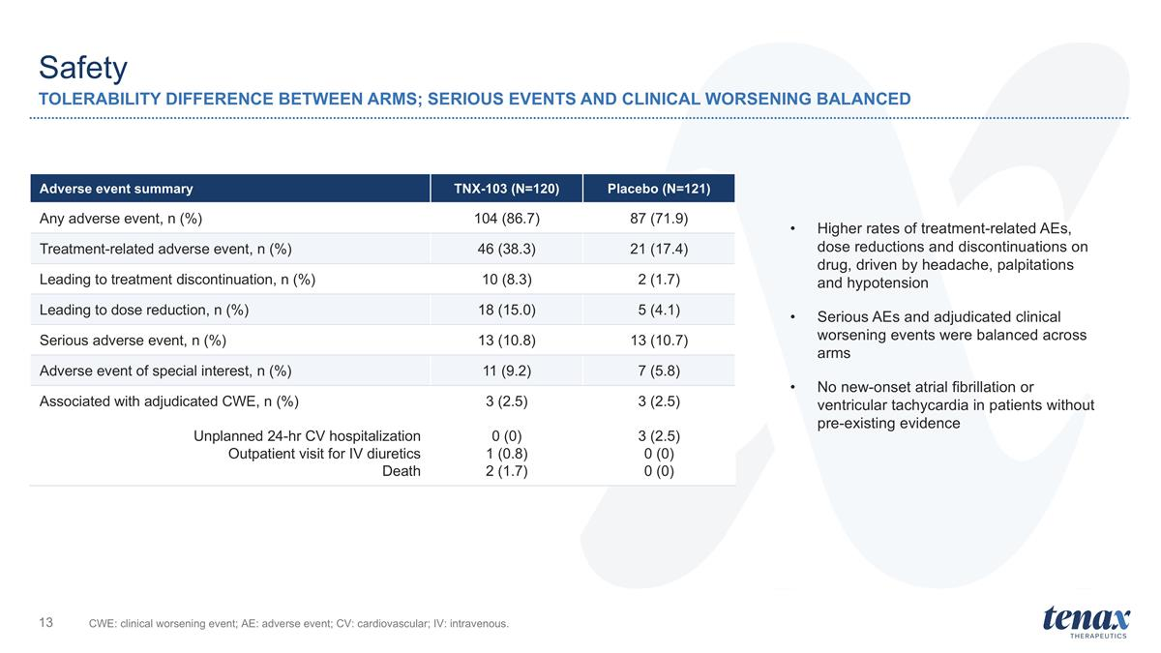
Safety TOLERABILITY DIFFERENCE BETWEEN ARMS; SERIOUS EVENTS AND CLINICAL WORSENING BALANCED CWE: clinical worsening event; AE: adverse event; CV: cardiovascular; IV: intravenous. Adverse event summary TNX-103 (N=120) Placebo (N=121) Any adverse event, n (%) 104 (86.7) 87 (71.9) Treatment-related adverse event, n (%) 46 (38.3) 21 (17.4) Leading to treatment discontinuation, n (%) 10 (8.3) 2 (1.7) Leading to dose reduction, n (%) 18 (15.0) 5 (4.1) Serious adverse event, n (%) 13 (10.8) 13 (10.7) Adverse event of special interest, n (%) 11 (9.2) 7 (5.8) Associated with adjudicated CWE, n (%) Unplanned 24-hr CV hospitalization Outpatient visit for IV diuretics Death 3 (2.5) 0 (0) 1 (0.8) 2 (1.7) 3 (2.5) 3 (2.5) 0 (0) 0 (0) Higher rates of treatment-related AEs, dose reductions and discontinuations on drug, driven by headache, palpitations and hypotension Serious AEs and adjudicated clinical worsening events were balanced across arms No new-onset atrial fibrillation or ventricular tachycardia in patients without pre-existing evidence

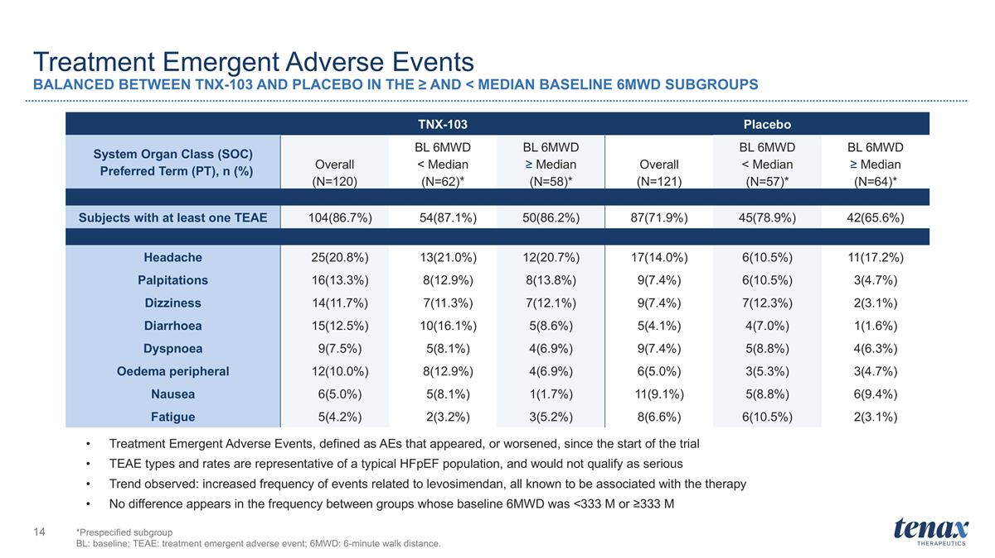
Treatment Emergent Adverse Events BALANCED BETWEEN TNX-103 AND PLACEBO IN THE ≥ AND < MEDIAN BASELINE 6MWD SUBGROUPS TNX-103 Placebo System Organ Class (SOC) Preferred Term (PT), n (%) Overall (N=120) BL 6MWD < Median (N=62)* BL 6MWD ≥ Median (N=58)* Overall (N=121) BL 6MWD < Median (N=57)* BL 6MWD ≥ Median (N=64)* Subjects with at least one TEAE 104(86.7%) 54(87.1%) 50(86.2%) 87(71.9%) 45(78.9%) 42(65.6%) Headache 25(20.8%) 13(21.0%) 12(20.7%) 17(14.0%) 6(10.5%) 11(17.2%) Palpitations 16(13.3%) 8(12.9%) 8(13.8%) 9(7.4%) 6(10.5%) 3(4.7%) Dizziness 14(11.7%) 7(11.3%) 7(12.1%) 9(7.4%) 7(12.3%) 2(3.1%) Diarrhoea 15(12.5%) 10(16.1%) 5(8.6%) 5(4.1%) 4(7.0%) 1(1.6%) Dyspnoea 9(7.5%) 5(8.1%) 4(6.9%) 9(7.4%) 5(8.8%) 4(6.3%) Oedema peripheral 12(10.0%) 8(12.9%) 4(6.9%) 6(5.0%) 3(5.3%) 3(4.7%) Nausea 6(5.0%) 5(8.1%) 1(1.7%) 11(9.1%) 5(8.8%) 6(9.4%) Fatigue 5(4.2%) 2(3.2%) 3(5.2%) 8(6.6%) 6(10.5%) 2(3.1%) *Prespecified subgroup BL: baseline; TEAE: treatment emergent adverse event; 6MWD: 6-minute walk distance. Treatment Emergent Adverse Events, defined as AEs that appeared, or worsened, since the start of the trial TEAE types and rates are representative of a typical HFpEF population, and would not qualify as serious Trend observed: increased frequency of events related to levosimendan, all known to be associated with the therapy No difference appears in the frequency between groups whose baseline 6MWD was <333 M or ≥333 M

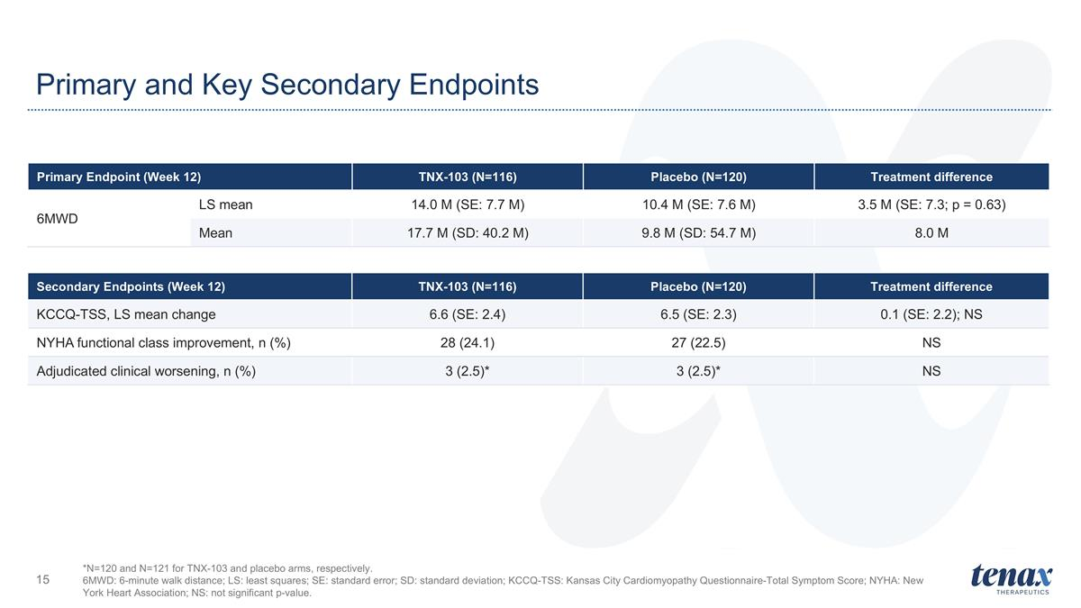
Primary and Key Secondary Endpoints *N=120 and N=121 for TNX-103 and placebo arms, respectively. 6MWD: 6-minute walk distance; LS: least squares; SE: standard error; SD: standard deviation; KCCQ-TSS: Kansas City Cardiomyopathy Questionnaire-Total Symptom Score; NYHA: New York Heart Association; NS: not significant p-value. Primary Endpoint (Week 12) TNX-103 (N=116) Placebo (N=120) Treatment difference 6MWD LS mean 14.0 M (SE: 7.7 M) 10.4 M (SE: 7.6 M) 3.5 M (SE: 7.3; p = 0.63) Mean 17.7 M (SD: 40.2 M) 9.8 M (SD: 54.7 M) 8.0 M Secondary Endpoints (Week 12) TNX-103 (N=116) Placebo (N=120) Treatment difference KCCQ-TSS, LS mean change 6.6 (SE: 2.4) 6.5 (SE: 2.3) 0.1 (SE: 2.2); NS NYHA functional class improvement, n (%) 28 (24.1) 27 (22.5) NS Adjudicated clinical worsening, n (%) 3 (2.5)* 3 (2.5)* NS

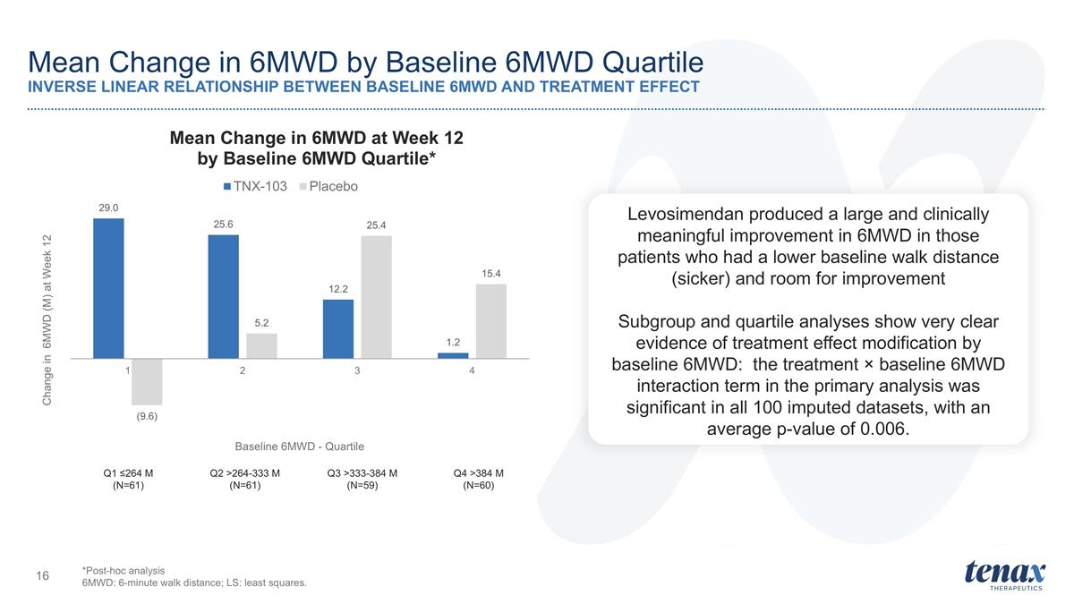
Mean Change in 6MWD by Baseline 6MWD Quartile INVERSE LINEAR RELATIONSHIP BETWEEN BASELINE 6MWD AND TREATMENT EFFECT Q1 ≤264 M (N=61) Q2 >264-333 M (N=61) Q3 >333-384 M (N=59) Q4 >384 M (N=60) *Post-hoc analysis 6MWD: 6-minute walk distance; LS: least squares. Levosimendan produced a large and clinically meaningful improvement in 6MWD in those patients who had a lower baseline walk distance (sicker) and room for improvement Subgroup and quartile analyses show very clear evidence of treatment effect modification by baseline 6MWD: the treatment × baseline 6MWD interaction term in the primary analysis was significant in all 100 imputed datasets, with an average p-value of 0.006.

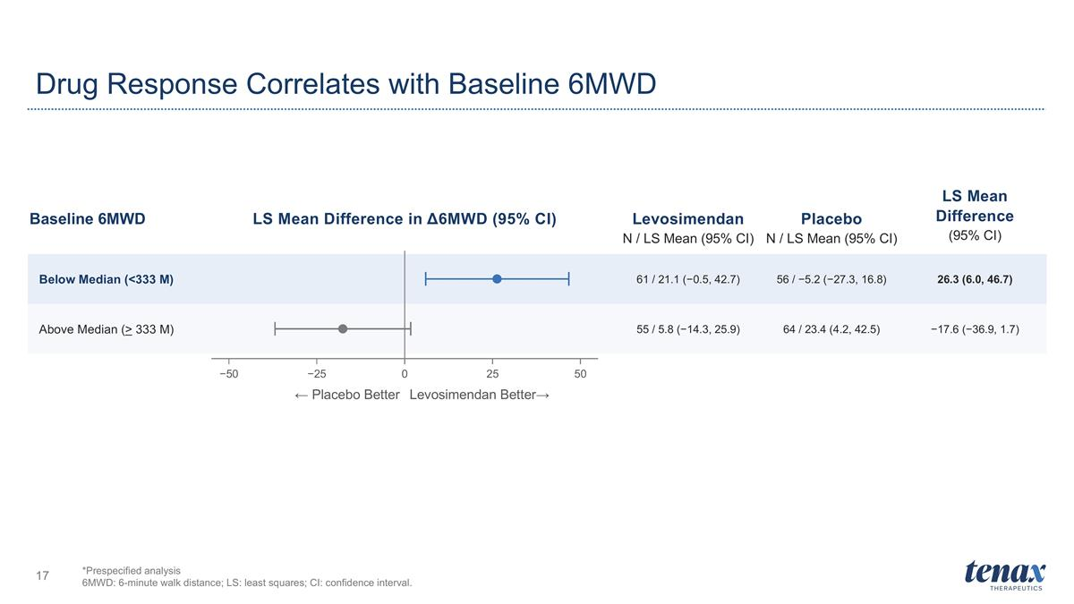
Drug Response Correlates with Baseline 6MWD *Prespecified analysis 6MWD: 6-minute walk distance; LS: least squares; CI: confidence interval. LS Mean Difference in Δ6MWD (95% CI) Levosimendan N / LS Mean (95% CI) Placebo N / LS Mean (95% CI) LS Mean Difference (95% CI) Baseline 6MWD Below Median (<333 M) 61 / 21.1 (−0.5, 42.7) 56 / −5.2 (−27.3, 16.8) 26.3 (6.0, 46.7) Above Median (> 333 M) 55 / 5.8 (−14.3, 25.9) 64 / 23.4 (4.2, 42.5) −17.6 (−36.9, 1.7) −50 −25 0 25 50 ← Placebo Better Levosimendan Better→

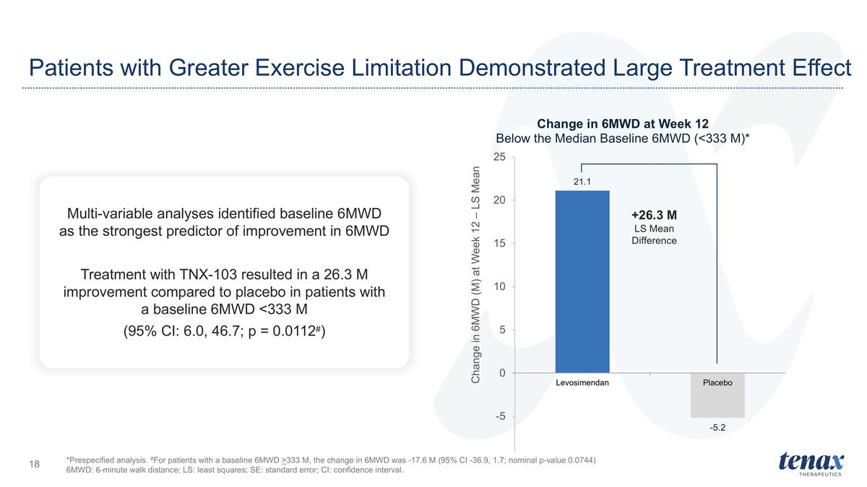
Patients with Greater Exercise Limitation Demonstrated Large Treatment Effect +26.3 M LS Mean Difference *Prespecified analysis. #For patients with a baseline 6MWD >333 M, the change in 6MWD was -17.6 M (95% CI -36.9, 1.7; nominal p-value 0.0744) 6MWD: 6-minute walk distance; LS: least squares; SE: standard error; CI: confidence interval. Multi-variable analyses identified baseline 6MWD as the strongest predictor of improvement in 6MWD Treatment with TNX-103 resulted in a 26.3 M improvement compared to placebo in patients with a baseline 6MWD <333 M (95% CI: 6.0, 46.7; p = 0.0112#)

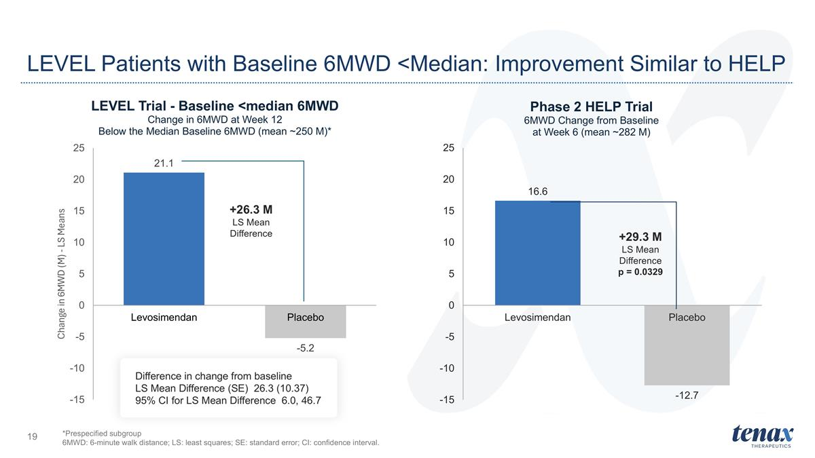
LEVEL Patients with Baseline 6MWD <Median: Improvement Similar to HELP +26.3 M LS Mean Difference +29.3 M LS Mean Difference p = 0.0329 *Prespecified subgroup 6MWD: 6-minute walk distance; LS: least squares; SE: standard error; CI: confidence interval. Difference in change from baseline LS Mean Difference (SE) 26.3 (10.37) 95% CI for LS Mean Difference 6.0, 46.7

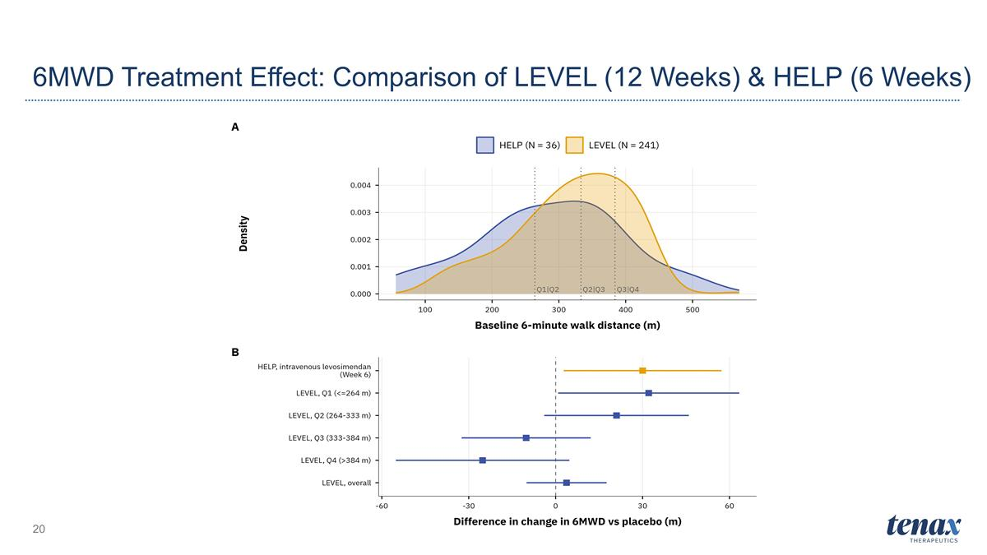
6MWD Treatment Effect: Comparison of LEVEL (12 Weeks) & HELP (6 Weeks)

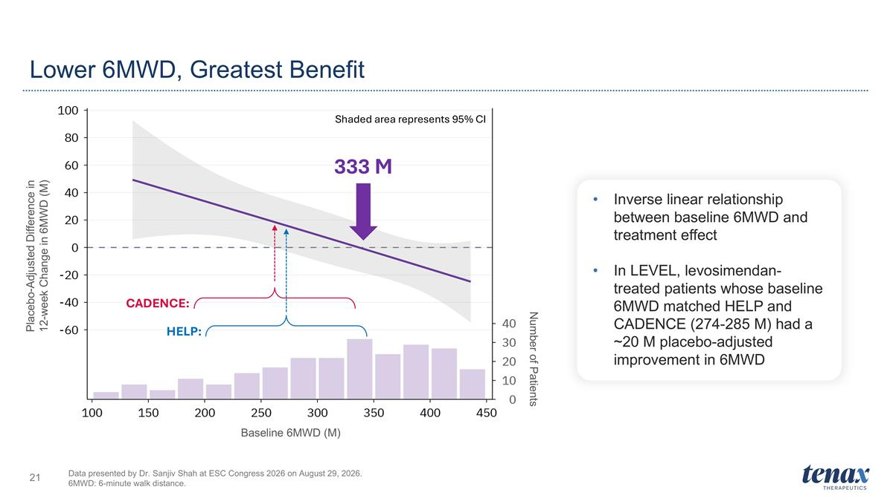
Lower 6MWD, Greatest Benefit Data presented by Dr. Sanjiv Shah at ESC Congress 2026 on August 29, 2026. 6MWD: 6-minute walk distance. 333 M CADENCE: HELP: Shaded area represents 95% CI Inverse linear relationship between baseline 6MWD and treatment effect In LEVEL, levosimendan-treated patients whose baseline 6MWD matched HELP and CADENCE (274-285 M) had a ~20 M placebo-adjusted improvement in 6MWD Placebo-Adjusted Difference in 12-week Change in 6MWD (M) Baseline 6MWD (M) Number of Patients

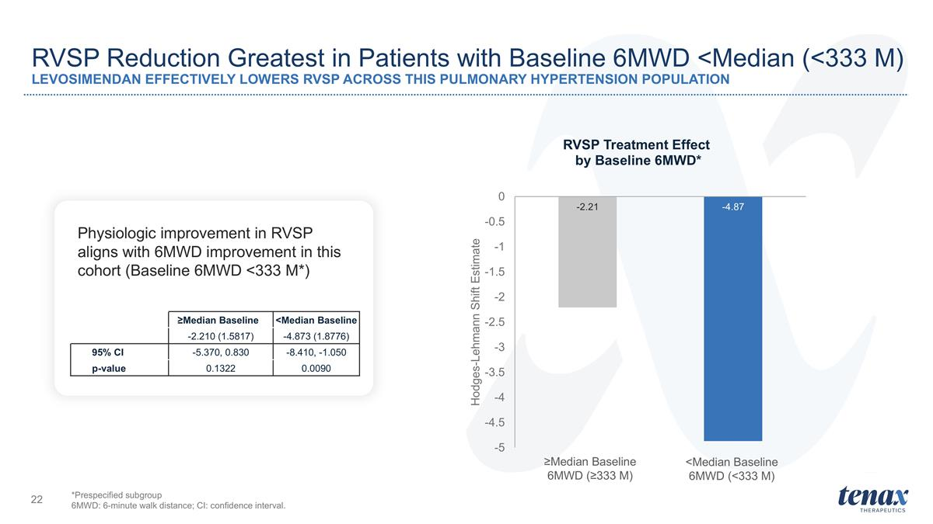
RVSP Reduction Greatest in Patients with Baseline 6MWD <Median (<333 M) LEVOSIMENDAN EFFECTIVELY LOWERS RVSP ACROSS THIS PULMONARY HYPERTENSION POPULATION *Prespecified subgroup 6MWD: 6-minute walk distance; CI: confidence interval. Physiologic improvement in RVSP aligns with 6MWD improvement in this cohort (Baseline 6MWD <333 M*) ≥Median Baseline 6MWD (≥333 M) <Median Baseline 6MWD (<333 M) ≥Median Baseline <Median Baseline -2.210 (1.5817) -4.873 (1.8776) 95% CI -5.370, 0.830 -8.410, -1.050 p-value 0.1322 0.0090

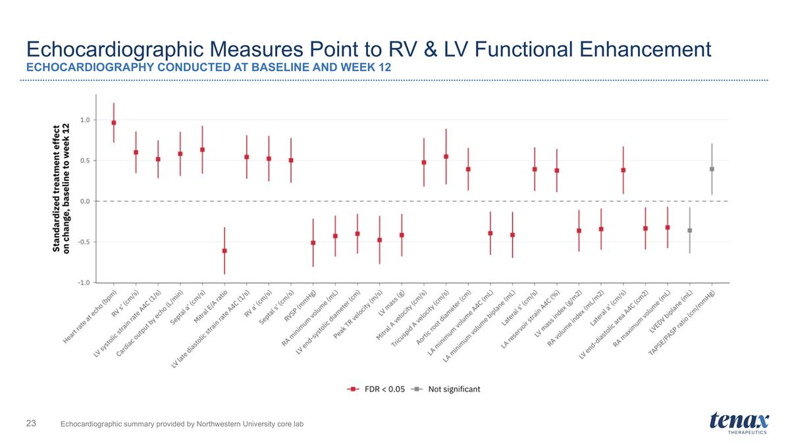
Echocardiographic Measures Point to RV & LV Functional Enhancement ECHOCARDIOGRAPHY CONDUCTED AT BASELINE AND WEEK 12 Echocardiographic summary provided by Northwestern University core lab

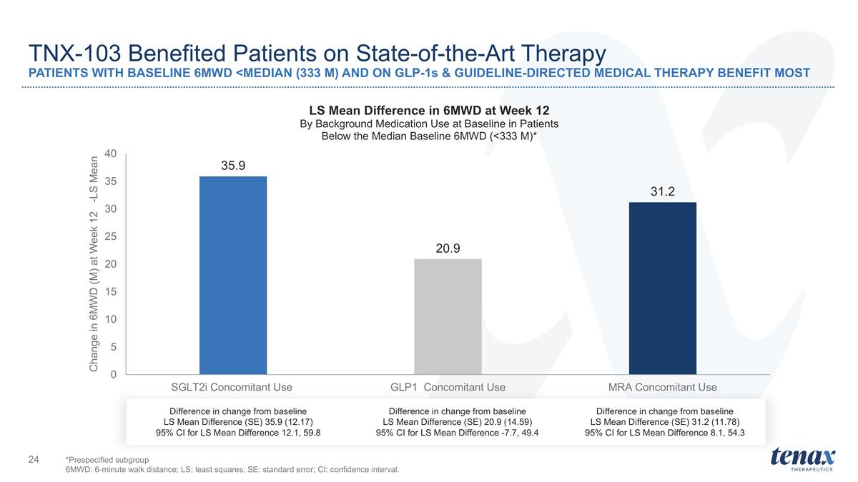
TNX-103 Benefited Patients on State-of-the-Art Therapy PATIENTS WITH BASELINE 6MWD <MEDIAN (333 M) AND ON GLP-1s & GUIDELINE-DIRECTED MEDICAL THERAPY BENEFIT MOST Difference in change from baseline LS Mean Difference (SE) 35.9 (12.17) 95% CI for LS Mean Difference 12.1, 59.8 Difference in change from baseline LS Mean Difference (SE) 20.9 (14.59) 95% CI for LS Mean Difference -7.7, 49.4 Difference in change from baseline LS Mean Difference (SE) 31.2 (11.78) 95% CI for LS Mean Difference 8.1, 54.3 *Prespecified subgroup 6MWD: 6-minute walk distance; LS: least squares; SE: standard error; CI: confidence interval.

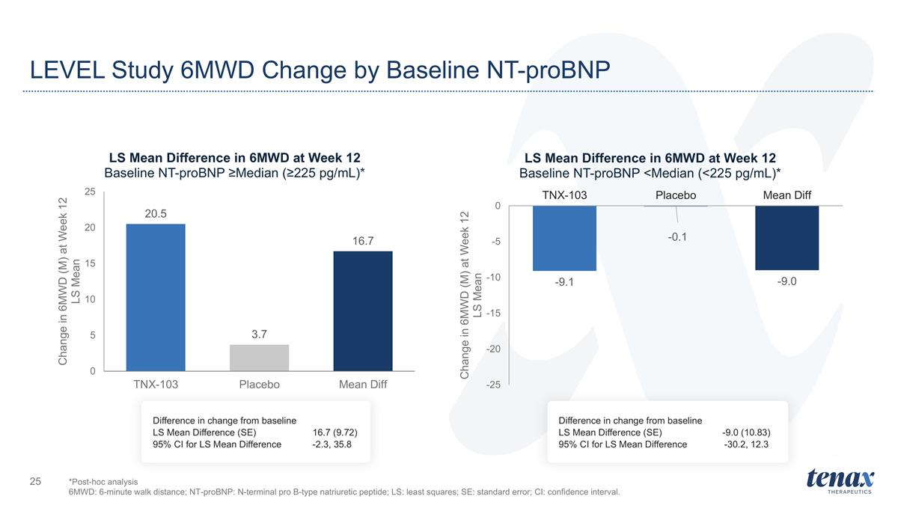
LEVEL Study 6MWD Change by Baseline NT-proBNP *Post-hoc analysis 6MWD: 6-minute walk distance; NT-proBNP: N-terminal pro B-type natriuretic peptide; LS: least squares; SE: standard error; CI: confidence interval. Difference in change from baseline LS Mean Difference (SE) 16.7 (9.72) 95% CI for LS Mean Difference -2.3, 35.8 Difference in change from baseline LS Mean Difference (SE) -9.0 (10.83) 95% CI for LS Mean Difference -30.2, 12.3

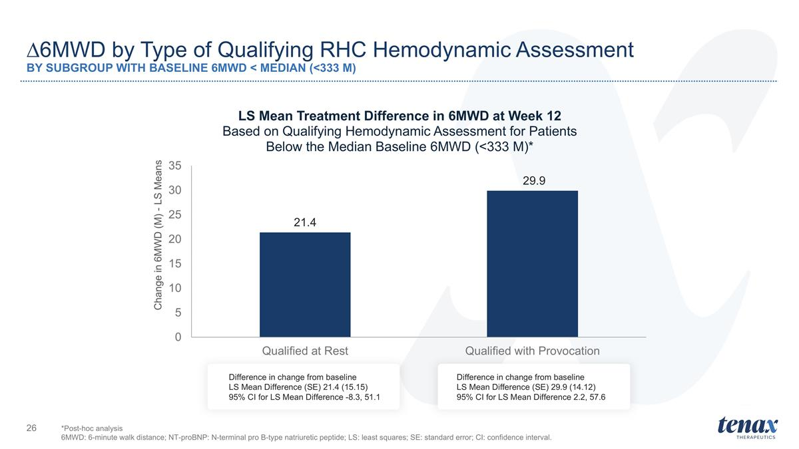
∆6MWD by Type of Qualifying RHC Hemodynamic Assessment BY SUBGROUP WITH BASELINE 6MWD < MEDIAN (<333 M) Difference in change from baseline LS Mean Difference (SE) 29.9 (14.12) 95% CI for LS Mean Difference 2.2, 57.6 Difference in change from baseline LS Mean Difference (SE) 21.4 (15.15) 95% CI for LS Mean Difference -8.3, 51.1 *Post-hoc analysis 6MWD: 6-minute walk distance; NT-proBNP: N-terminal pro B-type natriuretic peptide; LS: least squares; SE: standard error; CI: confidence interval.

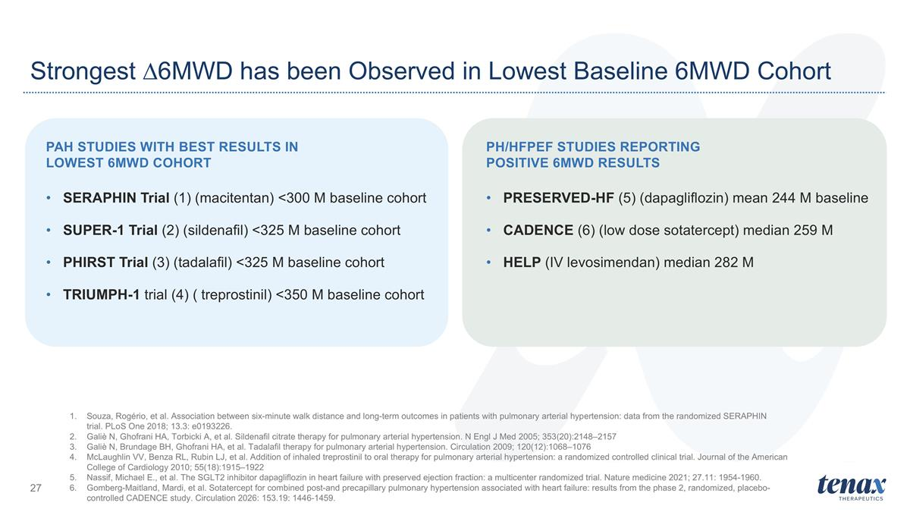
PAH Studies with Best Results in Lowest 6MWD Cohort SERAPHIN Trial (1) (macitentan) <300 M baseline cohort SUPER-1 Trial (2) (sildenafil) <325 M baseline cohort PHIRST Trial (3) (tadalafil) <325 M baseline cohort TRIUMPH-1 trial (4) ( treprostinil) <350 M baseline cohort PH/HFPEF Studies Reporting Positive 6MWD Results PRESERVED-HF (5) (dapagliflozin) mean 244 M baseline CADENCE (6) (low dose sotatercept) median 259 M HELP (IV levosimendan) median 282 M Strongest ∆6MWD has been Observed in Lowest Baseline 6MWD Cohort Souza, Rogério, et al. Association between six-minute walk distance and long-term outcomes in patients with pulmonary arterial hypertension: data from the randomized SERAPHIN trial. PLoS One 2018; 13.3: e0193226. Galiè N, Ghofrani HA, Torbicki A, et al. Sildenafil citrate therapy for pulmonary arterial hypertension. N Engl J Med 2005; 353(20):2148–2157 Galiè N, Brundage BH, Ghofrani HA, et al. Tadalafil therapy for pulmonary arterial hypertension. Circulation 2009; 120(12):1068–1076 McLaughlin VV, Benza RL, Rubin LJ, et al. Addition of inhaled treprostinil to oral therapy for pulmonary arterial hypertension: a randomized controlled clinical trial. Journal of the American College of Cardiology 2010; 55(18):1915–1922 Nassif, Michael E., et al. The SGLT2 inhibitor dapagliflozin in heart failure with preserved ejection fraction: a multicenter randomized trial. Nature medicine 2021; 27.11: 1954-1960. Gomberg-Maitland, Mardi, et al. Sotatercept for combined post-and precapillary pulmonary hypertension associated with heart failure: results from the phase 2, randomized, placebo-controlled CADENCE study. Circulation 2026: 153.19: 1446-1459.

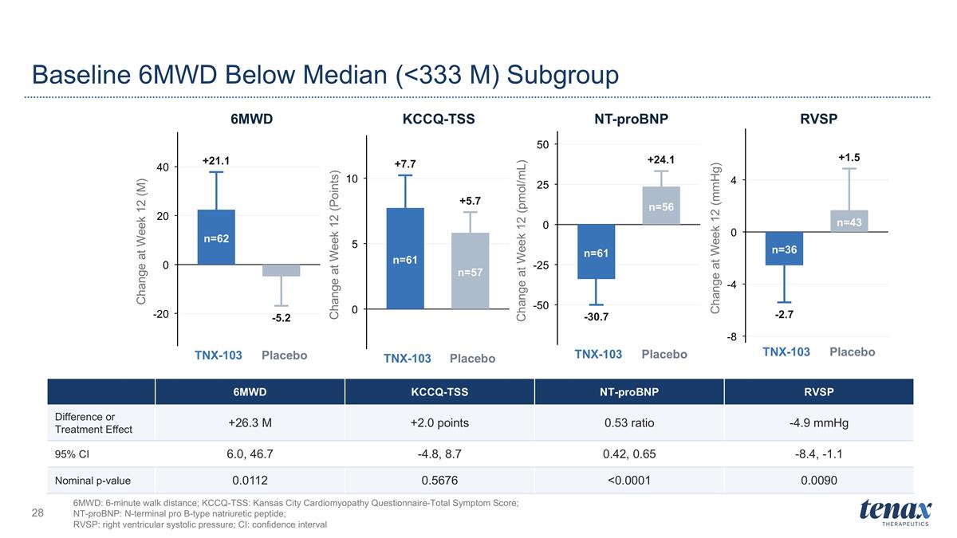
Baseline 6MWD Below Median (<333 M) Subgroup 6MWD: 6-minute walk distance; KCCQ-TSS: Kansas City Cardiomyopathy Questionnaire-Total Symptom Score; NT-proBNP: N-terminal pro B-type natriuretic peptide; RVSP: right ventricular systolic pressure; CI: confidence interval +21.1 -5.2 n=62 -20 0 20 40 TNX-103 Placebo Change at Week 12 (M) 6MWD +7.7 +5.7 n=61 n=57 0 5 10 TNX-103 Placebo Change at Week 12 (Points) KCCQ-TSS -30.7 +24.1 n=61 n=56 -50 -25 0 25 50 TNX-103 Placebo Change at Week 12 (pmol/mL) NT-proBNP -2.7 +1.5 n=36 n=43 -8 -4 0 4 TNX-103 Placebo Change at Week 12 (mmHg) RVSP 6MWD KCCQ-TSS NT-proBNP RVSP Difference or Treatment Effect +26.3 M +2.0 points 0.53 ratio -4.9 mmHg 95% CI 6.0, 46.7 -4.8, 8.7 0.42, 0.65 -8.4, -1.1 Nominal p-value 0.0112 0.5676 <0.0001 0.0090

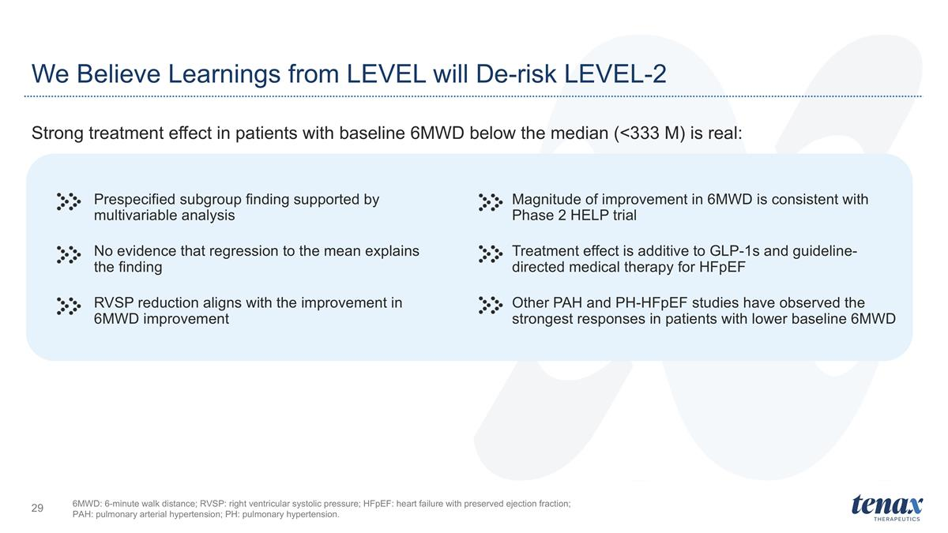
We Believe Learnings from LEVEL will De-risk LEVEL-2 Strong treatment effect in patients with baseline 6MWD below the median (<333 M) is real: Prespecified subgroup finding supported by multivariable analysis No evidence that regression to the mean explains the finding RVSP reduction aligns with the improvement in 6MWD improvement Magnitude of improvement in 6MWD is consistent with Phase 2 HELP trial Treatment effect is additive to GLP-1s and guideline-directed medical therapy for HFpEF Other PAH and PH-HFpEF studies have observed the strongest responses in patients with lower baseline 6MWD 6MWD: 6-minute walk distance; RVSP: right ventricular systolic pressure; HFpEF: heart failure with preserved ejection fraction; PAH: pulmonary arterial hypertension; PH: pulmonary hypertension.

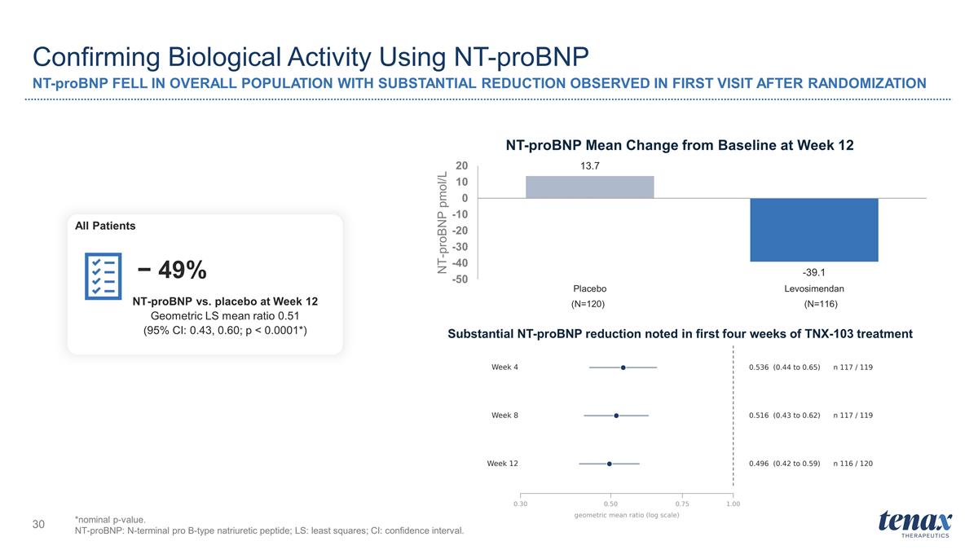
Confirming Biological Activity Using NT-proBNP NT-proBNP FELL IN OVERALL POPULATION WITH SUBSTANTIAL REDUCTION OBSERVED IN FIRST VISIT AFTER RANDOMIZATION *nominal p-value. NT-proBNP: N-terminal pro B-type natriuretic peptide; LS: least squares; CI: confidence interval. NT-proBNP vs. placebo at Week 12 Geometric LS mean ratio 0.51 (95% CI: 0.43, 0.60; p < 0.0001*) − 49% All Patients (N=120) (N=116) Substantial NT-proBNP reduction noted in first four weeks of TNX-103 treatment

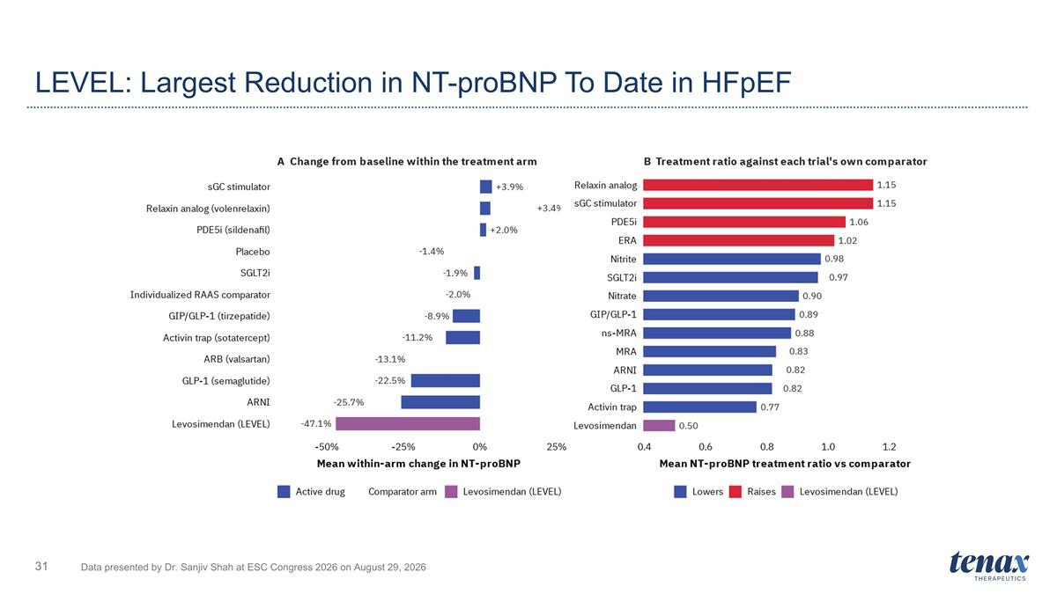
LEVEL: Largest Reduction in NT-proBNP To Date in HFpEF Data presented by Dr. Sanjiv Shah at ESC Congress 2026 on August 29, 2026

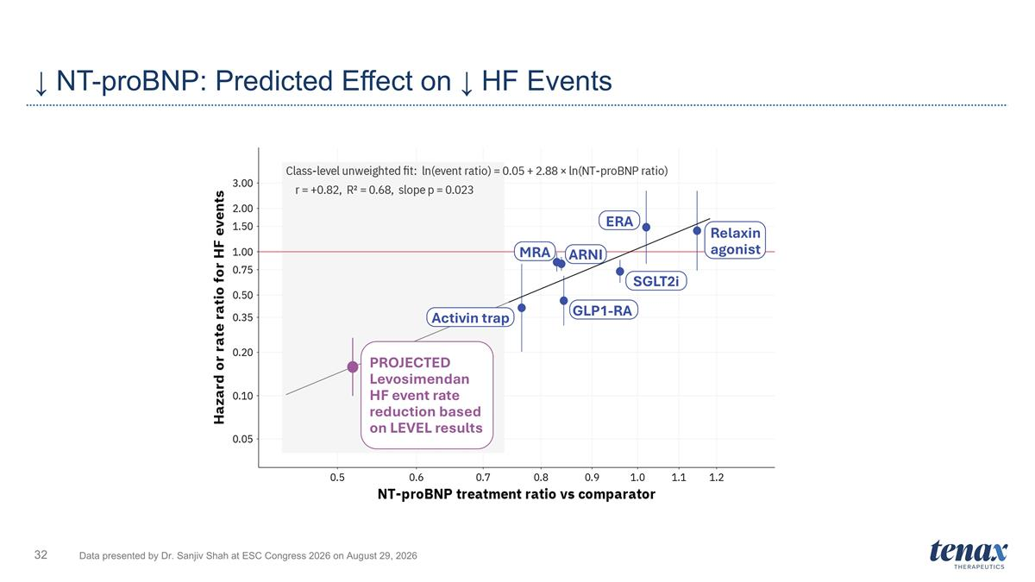
↓ NT-proBNP: Predicted Effect on ↓ HF Events Data presented by Dr. Sanjiv Shah at ESC Congress 2026 on August 29, 2026 Activin trap SGLT2i Relaxin agonist MRA PROJECTED Levosimendan HF event rate reduction based on LEVEL results GLP1-RA ARNI ERA

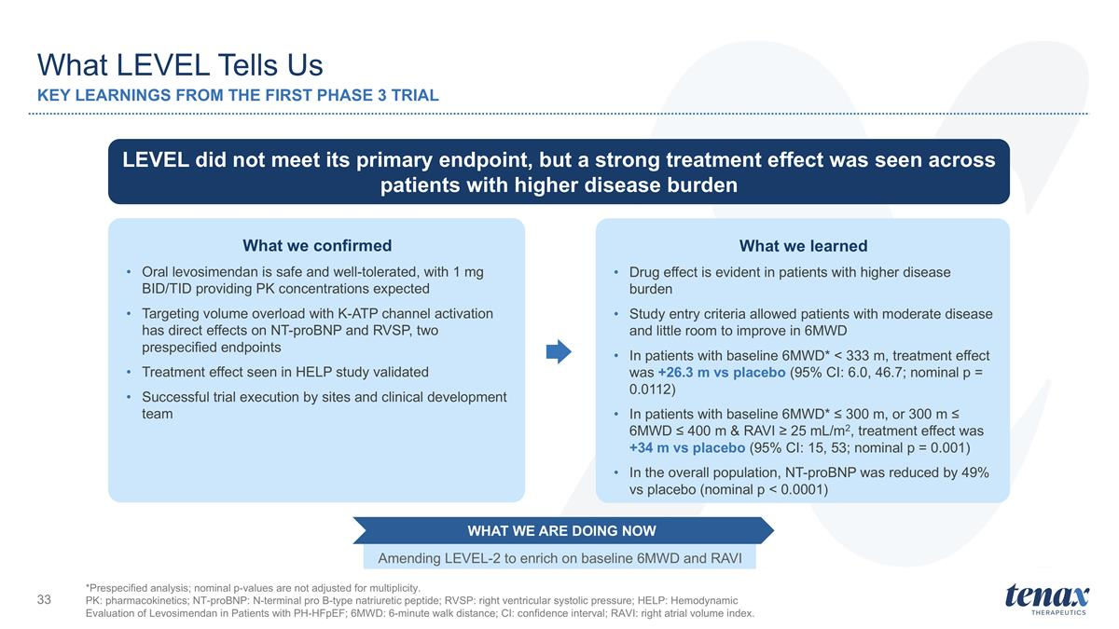
What LEVEL Tells Us KEY LEARNINGS FROM THE FIRST PHASE 3 TRIAL *Prespecified analysis; nominal p-values are not adjusted for multiplicity. PK: pharmacokinetics; NT-proBNP: N-terminal pro B-type natriuretic peptide; RVSP: right ventricular systolic pressure; HELP: Hemodynamic Evaluation of Levosimendan in Patients with PH-HFpEF; 6MWD: 6-minute walk distance; CI: confidence interval; RAVI: right atrial volume index. LEVEL did not meet its primary endpoint, but a strong treatment effect was seen across patients with higher disease burden What we confirmed Oral levosimendan is safe and well-tolerated, with 1 mg BID/TID providing PK concentrations expected Targeting volume overload with K-ATP channel activation has direct effects on NT-proBNP and RVSP, two prespecified endpoints Treatment effect seen in HELP study validated Successful trial execution by sites and clinical development team What we learned Drug effect is evident in patients with higher disease burden Study entry criteria allowed patients with moderate disease and little room to improve in 6MWD In patients with baseline 6MWD* < 333 m, treatment effect was +26.3 m vs placebo (95% CI: 6.0, 46.7; nominal p = 0.0112) In patients with baseline 6MWD* ≤ 300 m, or 300 m ≤ 6MWD ≤ 400 m & RAVI ≥ 25 mL/m2, treatment effect was +34 m vs placebo (95% CI: 15, 53; nominal p = 0.001) In the overall population, NT-proBNP was reduced by 49% vs placebo (nominal p < 0.0001) Amending LEVEL-2 to enrich on baseline 6MWD and RAVI WHAT WE ARE DOING NOW

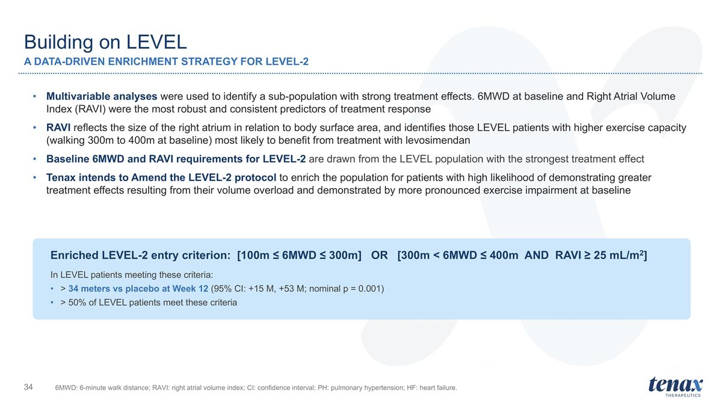
Building on LEVEL A DATA-DRIVEN ENRICHMENT STRATEGY FOR LEVEL-2 6MWD: 6-minute walk distance; RAVI: right atrial volume index; CI: confidence interval; PH: pulmonary hypertension; HF: heart failure. Multivariable analyses were used to identify a sub-population with strong treatment effects. 6MWD at baseline and Right Atrial Volume Index (RAVI) were the most robust and consistent predictors of treatment response RAVI reflects the size of the right atrium in relation to body surface area, and identifies those LEVEL patients with higher exercise capacity (walking 300m to 400m at baseline) most likely to benefit from treatment with levosimendan Baseline 6MWD and RAVI requirements for LEVEL-2 are drawn from the LEVEL population with the strongest treatment effect Tenax intends to Amend the LEVEL-2 protocol to enrich the population for patients with high likelihood of demonstrating greater treatment effects resulting from their volume overload and demonstrated by more pronounced exercise impairment at baseline Enriched LEVEL-2 entry criterion: [100m ≤ 6MWD ≤ 300m] OR [300m < 6MWD ≤ 400m AND RAVI ≥ 25 mL/m2] In LEVEL patients meeting these criteria: > 34 meters vs placebo at Week 12 (95% CI: +15 M, +53 M; nominal p = 0.001) > 50% of LEVEL patients meet these criteria

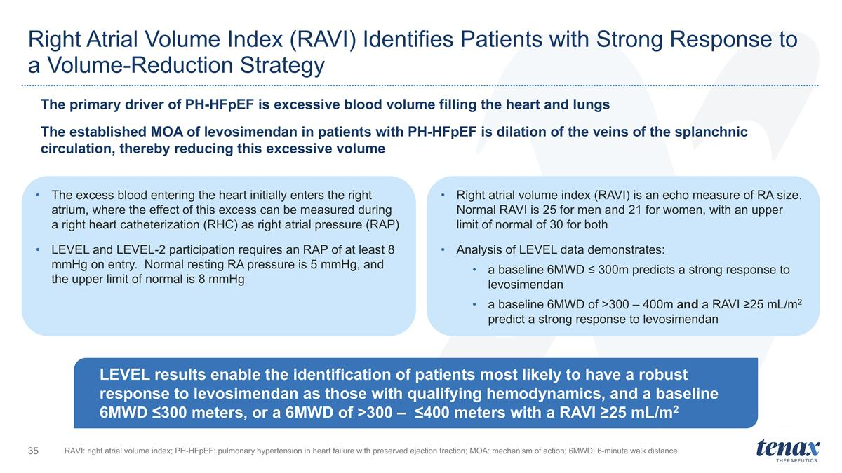
Right Atrial Volume Index (RAVI) Identifies Patients with Strong Response to a Volume-Reduction Strategy The excess blood entering the heart initially enters the right atrium, where the effect of this excess can be measured during a right heart catheterization (RHC) as right atrial pressure (RAP) LEVEL and LEVEL-2 participation requires an RAP of at least 8 mmHg on entry. Normal resting RA pressure is 5 mmHg, and the upper limit of normal is 8 mmHg Right atrial volume index (RAVI) is an echo measure of RA size. Normal RAVI is 25 for men and 21 for women, with an upper limit of normal of 30 for both Analysis of LEVEL data demonstrates: a baseline 6MWD ≤ 300m predicts a strong response to levosimendan a baseline 6MWD of >300 – 400m and a RAVI ≥25 mL/m2 predict a strong response to levosimendan RAVI: right atrial volume index; PH-HFpEF: pulmonary hypertension in heart failure with preserved ejection fraction; MOA: mechanism of action; 6MWD: 6-minute walk distance. LEVEL results enable the identification of patients most likely to have a robust response to levosimendan as those with qualifying hemodynamics, and a baseline 6MWD ≤300 meters, or a 6MWD of >300 – ≤400 meters with a RAVI ≥25 mL/m2 The primary driver of PH-HFpEF is excessive blood volume filling the heart and lungs The established MOA of levosimendan in patients with PH-HFpEF is dilation of the veins of the splanchnic circulation, thereby reducing this excessive volume

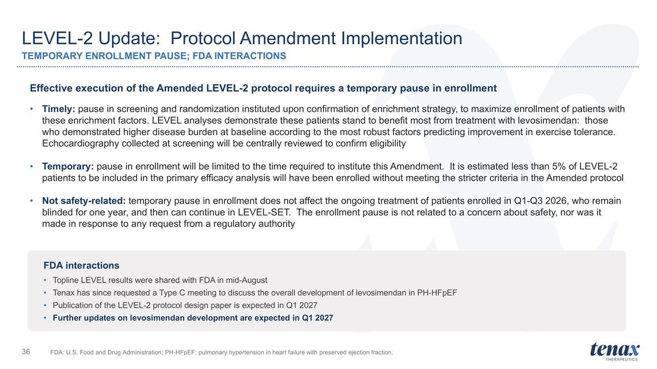
LEVEL-2 Update: Protocol Amendment Implementation TEMPORARY ENROLLMENT PAUSE; FDA INTERACTIONS FDA: U.S. Food and Drug Administration; PH-HFpEF: pulmonary hypertension in heart failure with preserved ejection fraction. Effective execution of the Amended LEVEL-2 protocol requires a temporary pause in enrollment Timely: pause in screening and randomization instituted upon confirmation of enrichment strategy, to maximize enrollment of patients with these enrichment factors. LEVEL analyses demonstrate these patients stand to benefit most from treatment with levosimendan: those who demonstrated higher disease burden at baseline according to the most robust factors predicting improvement in exercise tolerance. Echocardiography collected at screening will be centrally reviewed to confirm eligibility Temporary: pause in enrollment will be limited to the time required to institute this Amendment. It is estimated less than 5% of LEVEL-2 patients to be included in the primary efficacy analysis will have been enrolled without meeting the stricter criteria in the Amended protocol Not safety-related: temporary pause in enrollment does not affect the ongoing treatment of patients enrolled in Q1-Q3 2026, who remain blinded for one year, and then can continue in LEVEL-SET. The enrollment pause is not related to a concern about safety, nor was it made in response to any request from a regulatory authority FDA interactions Topline LEVEL results were shared with FDA in mid-August Tenax has since requested a Type C meeting to discuss the overall development of levosimendan in PH-HFpEF Publication of the LEVEL-2 protocol design paper is expected in Q1 2027 Further updates on levosimendan development are expected in Q1 2027

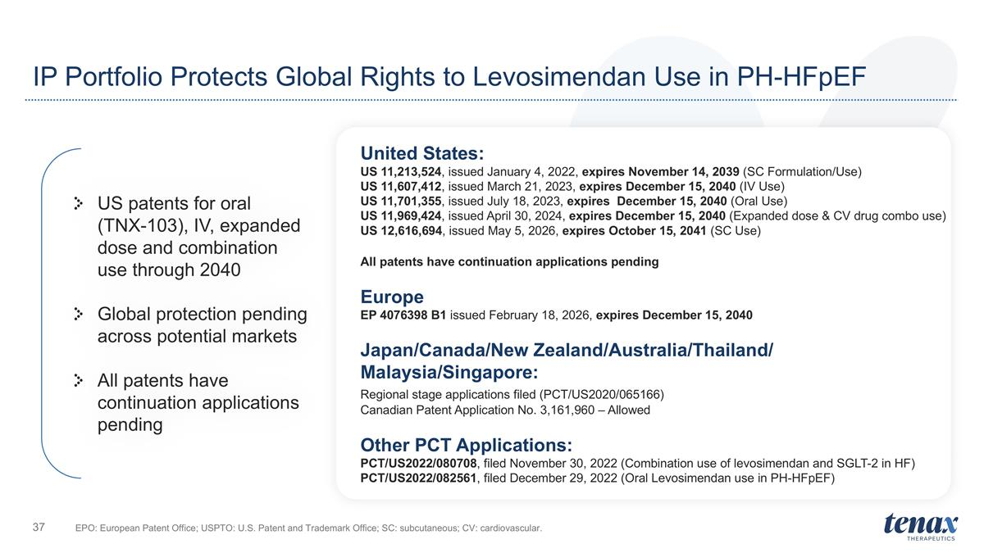
IP Portfolio Protects Global Rights to Levosimendan Use in PH-HFpEF United States: US 11,213,524, issued January 4, 2022, expires November 14, 2039 (SC Formulation/Use) US 11,607,412, issued March 21, 2023, expires December 15, 2040 (IV Use) US 11,701,355, issued July 18, 2023, expires December 15, 2040 (Oral Use) US 11,969,424, issued April 30, 2024, expires December 15, 2040 (Expanded dose & CV drug combo use) US 12,616,694, issued May 5, 2026, expires October 15, 2041 (SC Use) All patents have continuation applications pending Europe EP 4076398 B1 issued February 18, 2026, expires December 15, 2040 Japan/Canada/New Zealand/Australia/Thailand/ Malaysia/Singapore: Regional stage applications filed (PCT/US2020/065166) Canadian Patent Application No. 3,161,960 – Allowed Other PCT Applications: PCT/US2022/080708, filed November 30, 2022 (Combination use of levosimendan and SGLT-2 in HF) PCT/US2022/082561, filed December 29, 2022 (Oral Levosimendan use in PH-HFpEF) US patents for oral (TNX-103), IV, expanded dose and combination use through 2040 Global protection pending across potential markets All patents have continuation applications pending EPO: European Patent Office; USPTO: U.S. Patent and Trademark Office; SC: subcutaneous; CV: cardiovascular.

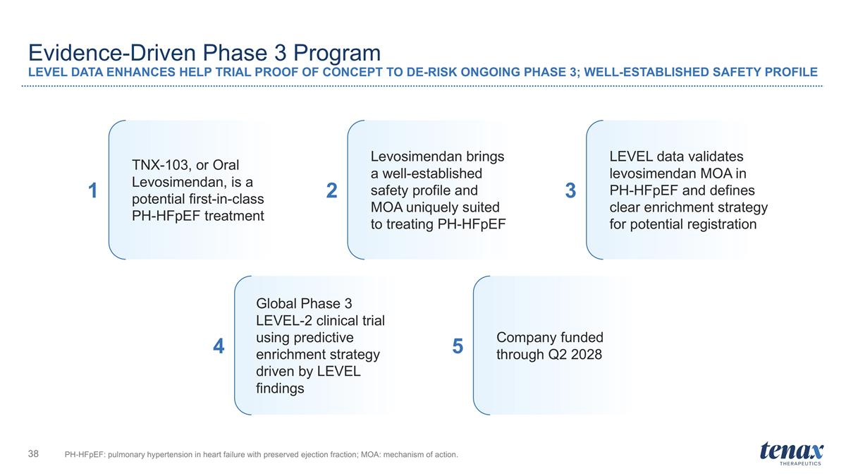
Evidence-Driven Phase 3 Program LEVEL DATA ENHANCES HELP TRIAL PROOF OF CONCEPT TO DE-RISK ONGOING PHASE 3; WELL-ESTABLISHED SAFETY PROFILE PH-HFpEF: pulmonary hypertension in heart failure with preserved ejection fraction; MOA: mechanism of action. TNX-103, or Oral Levosimendan, is a potential first-in-class PH-HFpEF treatment Levosimendan brings a well-established safety profile and MOA uniquely suited to treating PH-HFpEF Company funded through Q2 2028 1 2 3 4 5 LEVEL data validates levosimendan MOA in PH-HFpEF and defines clear enrichment strategy for potential registration Global Phase 3 LEVEL-2 clinical trial using predictive enrichment strategy driven by LEVEL findings


Developing a therapy uniquely suited for PH-HFpEF

